

Statement of Work
  - Prepared for – Drax energy Solutions limited
  - 16/10/2025
nasstar.com

Contents

1 Overview 4
1.1 Background 4
2 Proposed Solution 5
2.1 Requirements 5
2.2 Solution Summary 5
3 Delivery 6
3.1 Project Delivery 6
Out of scope 7
4 Dependencies, Responsibilities and Assumptions 8
4.1 Prerequisites and Dependencies 8
4.1.1 Prerequisites 8
4.2 Technical Assumptions 8
4.3 General Assumptions 8
4.4 Customer Responsibilities 8
4.5 Nasstar Responsibilities 9
4.6 Known Risks and Constraints 9
4.6.1 Constraints 9
4.6.2 Risks 10
5 Financial 11
5.1 Pricing 11
5.2 Work Package breakdown, Invoicing and Payment Terms 12
6 Terms and Conditions 13

Version Control Table
Version | Date | Author | Description of Changes
0.1 | 09/10/2025 | Ross Broady | Draft
0.2 | 16/10/2025 | Gianluca Formica | Peer Review
0.3 | Click or tap to enter a date. | TBC | Practice Review
0.4 | Click or tap to enter a date. | TBC | Project Review
0.5 | Click or tap to enter a date. | Dan O’Connor | Commercial Review
0.6 | Click or tap to enter a date. | Dan O’Connor | Release (DRAFT)

Overview
This Statement of Work (SoW) defines the solution being proposed by Nasstar for Drax energy Solutions limited (hereinafter “Drax energy Solutions limited” or the “Customer”). It contains information on pricing, scope definition, roles and responsibilities, potential project risks, and technical assumptions.

Background
This agreement is for the continuation of consultancy resources to facilitate strategic business activity at Drax.
As part of the engagement between Drax and Nasstar it has been identified that the augmentation resource provides significant benefit by delivering business value specific to governance and regulatory needs.
The agreement is for staff augmentation and has no fixed deliverables.

Proposed Solution

Requirements
Reference | Business Requirement
BR001 | 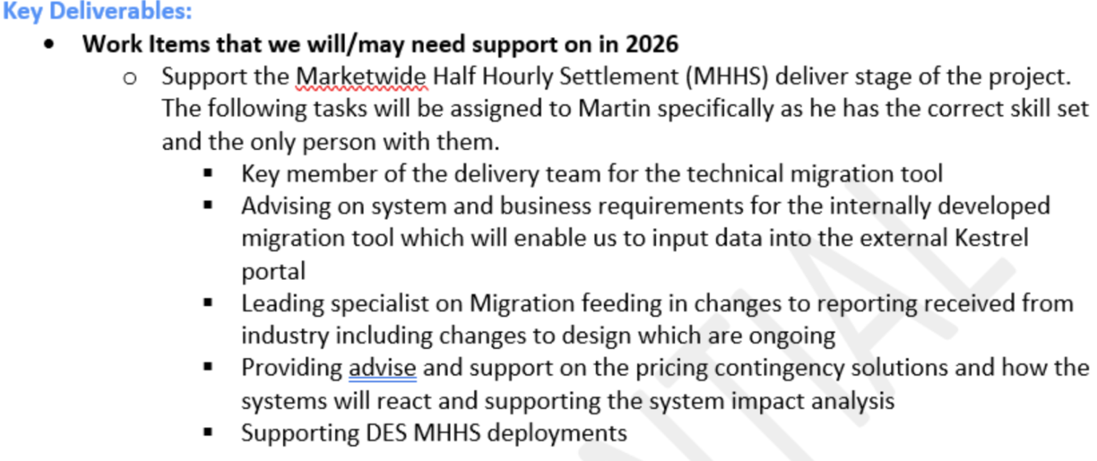

Solution Summary
Haven Power Limited have requested to extend the contract engagement for Martin Alabone for a maximum of 125 days beginning on Thursday 1st January 2026.
The expectation is that Martin will be required to complete the following activities called out in the table above under Business Requirement.
Key task will be continuing to advise on technical and business considerations for the MHHS project team, as well as reviewing and challenging proposed solutions to ensure that that all key scenarios are considered.

Contract: max 125 days from January 2026.

Delivery
This section provides the detail on the tasks, services and infrastructure that will be deployed as part of this Statement of Work.

Project Delivery

Work Package 1.0
Title | Senior Business System Analyst
Practice | Engineering - Software
Commercial Basis | Time and Materials
Objectives | - Support IT and Commercial as regards Regulatory changes that must be delivered throughout 2026..  - Support the Market wide Half Hourly Settlement (MHHS) define and design stages of the project, together with go-live and migration
High-level activities to achieve objectives | - Provide resource with the necessary skill set
Method of acceptance | - Time evidenced
Additional information | Please note that due to the Time and Materials nature of this engagement, the above outlined activities may not be able to be achieved within our estimate. Should we believe that we will require an increase to time and budget then we will raise this with Drax energy Solutions limited for approval.  The Time & Material estimate is based on the following roles and quantity:  Senior Business Analyst  - 125 days @ £740 per day
Price | £ 92,500.00

Out of scope
Item | Description
General | Anything not explicitly defined in this SoW is deemed to be out of scope.
General | Nasstar will not provide any form of project management or project co-ordination

Dependencies, Responsibilities and Assumptions
The following section outlines assumptions, constraints and customer dependencies that are relevant to the scope of the project and the costs included in the ‘Pricing’ section and are in addition to any assumptions set out in the General Terms.
Should any of the following not be made available then further time and effort/cost may be required. Any change to scope will be discussed at the earliest opportunity and a Request for Change (“RFC”) will be produced for approval.

Prerequisites and Dependencies

Prerequisites
- The Customer will assign someone to the role of Project Manager, who will provide input to the project schedule, manage the Customer’s issues and risks, manage their resources and generally act as the focal point for communication between Nasstar and the Customer.
- The Customer will assign resources to work on this project that have appropriate understanding of the Customer’s environment and a full understanding of the business drivers and goals for the project.
- The Customer will identify security clearance requirements for Nasstar resources and provide the required clearance prior to the contract commencement where required.

Technical Assumptions
- Permissions to access all affected areas are provided before work commences. The permissions required will be discussed during the discovery workshop.
- Availability of relevant Customer technical teams with site-specific knowledge.

General Assumptions
- Nasstar by default will conduct the workshops and the delivery elements of the project via remote working.
- For any services delivered onsite at the Customer’s location, the Customer will provide Nasstar consultants with adequate and appropriate accommodation at the site, as well as access to any data as may be required to complete the deliverables.
- The work is being carried out within Standard UK Business Hours, on a Business Day, unless specified otherwise.
- The Customer’s assigned resources will be available to work with Nasstar during the project.
- The Customer will provide sufficient remote access and permissions to allow Nasstar to deliver this Statement of Work.

Customer Responsibilities
- Complete any assigned Prerequisites.
- Provide the Nasstar Project Team with any security related documents and policies.
- Ensure the Nasstar Project Team is made aware of any specific security standards that may be applicable to the scope of this Statement of Work.
- The leadership of the project and provision of a dedicated Project Manager/escalation contact points.
- The timely provision of Purchase Orders in accordance with the agreed plan.
- Ensuring all necessary prerequisites are in place prior to scheduled Nasstar work commencing; failure to do so may incur a charge at the prevailing Nasstar rate.
- Ensuring all necessary information has been provided prior to scheduled Nasstar work commencing. Overall management of the project and maintenance of the project plan.
- If accounts / access or clearance for Nasstar is not in place prior to commencing work – any delays caused by additional vetting/ account creation may incur additional charges.

Nasstar Responsibilities
- Nasstar are responsible for the deliverables contained within the scope of this SoW.

Known Risks and Constraints

Constraints
- Nasstar requires a minimum of 2 weeks’ notice from the Customer to mobilise resources.
- Nasstar require a minimum of 2 weeks’ notice to stand down confirmed resources without charge. Where a Customer provides less than 2 weeks’ notice, a charge equal to the standard day rate charge will apply for those resources
- Additional time needed because of issues requiring extensive support from either Microsoft or other vendors will be billed on a Time and Materials basis. The specific support issue and estimated effort will be agreed upon mutually by the Customer and Nasstar prior to any additional billing.
- This Statement of Work must be completed within 129 days of its commencement. Nasstar reserves the right to modify its fees for any extension beyond this duration unless otherwise agreed upon by both Nasstar and the Customer.
- Please note that this SOW is priced based on a contiguous delivery schedule as outlined above, with no breaks/delays between corresponding work packages. Nasstar reserves the right to modify its fees if this constraint is broken, unless otherwise agreed upon by both parties.
- The execution of the work described in this Statement of Work in no way absolves the Customer from the responsibility of the security position this work may impact.
- Where specific Documentation is identified for sign-off by the customer at specified milestones described in the individual work packages in this Statement of Work, Nasstar will submit completed Documentation deliverables for the Customers’ review and approval. Within three business days from the date of submission, the Customer must either accept the Documentation or provide a written notice by email to the Nasstar Project Manager rejecting the Documentation, including a single, complete list of reason(s) for rejection. The Documentation will be deemed accepted unless the Customer provides a rejection notice as described above. The Customers’ use or partial use of the Documentation will constitute acceptance of that Documentation.
- Nasstar will correct problems with the Documentation that are identified in the written rejection notice, as described above, and within the scope of the Documentation, after which the Documentation will be deemed accepted. Issues that are outside the scope, and feedback provided after the Documentation has been deemed accepted, will be addressed as a potential change of scope pursuant to the Change Control process.

Risks
This section provides a summary of any known risks to the project during the initial discovery/proposal phase.
Item | Description
General | No risks have been identified at the point this document has been created.

Financial
The pricing detailed below is based on the information provided.
During the initial phases of the project the information will be validated and any changes in scope may result in a Request for Change being issued.
All pricing in this document is valid for 30 days from the date of issue.

Pricing
Item | Description |  | Qty | Unit |  | Price
Professional Services
Note: Following the Engagement Readiness, Nasstar will assess the original design against any new or changed requirements and will validate the costs for the remaining engagement.  Work Packages 1.0 – 6.0 as detailed in the above SOW. |  |  | 1 |  |  |  | £92,500.00
Subtotal |  |  |  |  |  |  | £ 92,500.00
Professional Services / One-Off Total |  |  |  |  |  |  | £ 92,500.00

Pricing Notes:
All days are assumed at 7.5 working hours per days. Days will be billed in half day or full day increments or part thereof.
In the event of third-party cost increases (e.g, Equipment, software licenses,), Nasstar shall notify the client promptly. Any resulting price adjustments will be negotiated in good faith and documented in a change order.

Work Package breakdown, Invoicing and Payment Terms
The Customer will pay the Charges in accordance with clause 5 in the General Terms. Drax will be invoiced monthly in arrears for time consumed, consumed time will be validated against time cards submitted by the Nasstar resource.

Terms and Conditions
- This Contract is governed by and is subject to the Nasstar General Terms and the other terms and conditions specified in the Order Form, which may include (but is not limited to) Professional Services Terms where such services are to be provided by Nasstar to the Customer as part of the Order.
- The Customer’s own terms and conditions are excluded and do not apply to the Contract.
- The usage of Software is subject to the usage and other licence terms applicable to such Software. The Customer may be required to enter into an End User Licence Agreement (EULA) in respect of the Software, and the Customer undertakes to comply with the terms of such EULA.
- If Microsoft offers to pay for this Statement of Work (or any part of it) and that funding is subsequently withheld for any reason, including the Customer’s failure to activate sufficient Microsoft licences or comply with sign-off requirements, Nasstar will invoice the Customer for the amount withheld and the Customer will pay such invoice within 30 days.

Authorisation to proceed
Upon signature by both parties,* this document becomes a Statement of Work between Drax energy Solutions limited and Nasstar, and is subject to the terms and conditions set out in the Master Software and Services Agreement (“MSA”) between the parties.

For and on behalf of Nasstar  Signature:  _______________________  Name:  _______________________  Title:  _______________________  Date:  _______________________ | For and on behalf of Drax energy Solutions limited:  Signature:  ________________________  Name:  ________________________  Title:  ________________________  Date: _________________________  PO Ref: _________________________ (if applicable)

